Students: Andrew-Nicholas Rusu, Patrick Bucioaca
Date: October 15th, 2026
Class: .NET Development
Teacher: Reza Mirsalari
All Reporting of C# C# Classes, Methods, Properties, Inheritance, and Interfaces(Assignment 7)

Creation of several delivery objects.
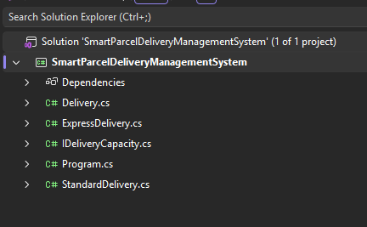

Valid and invalid property assignments to demonstrate validation.
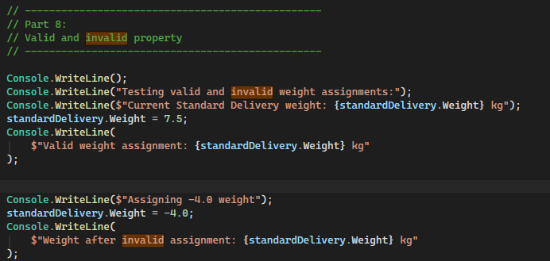

Different delivery types.
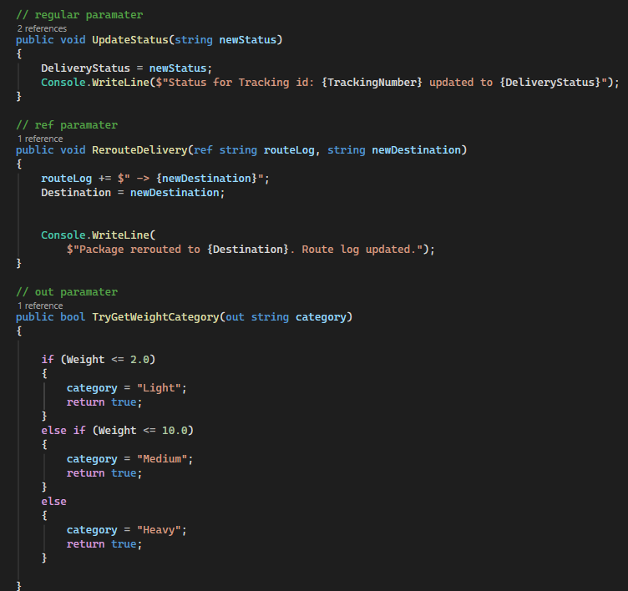

Calculation of delivery costs.
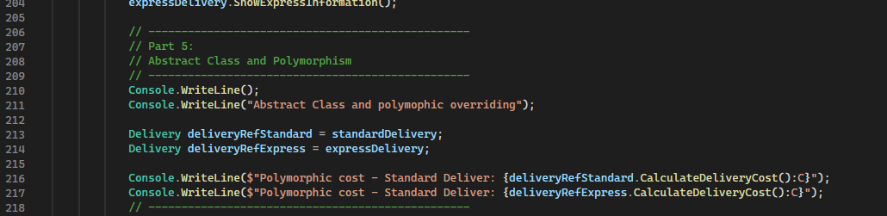

The required parameter-passing techniques.
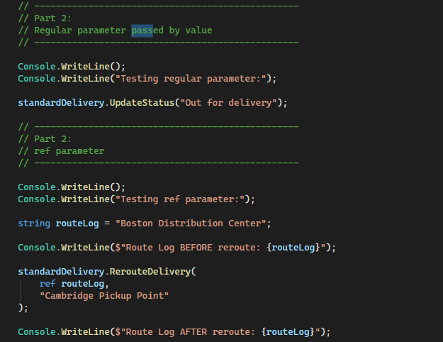

Static versus instance members.
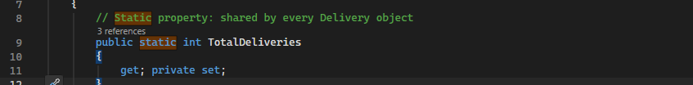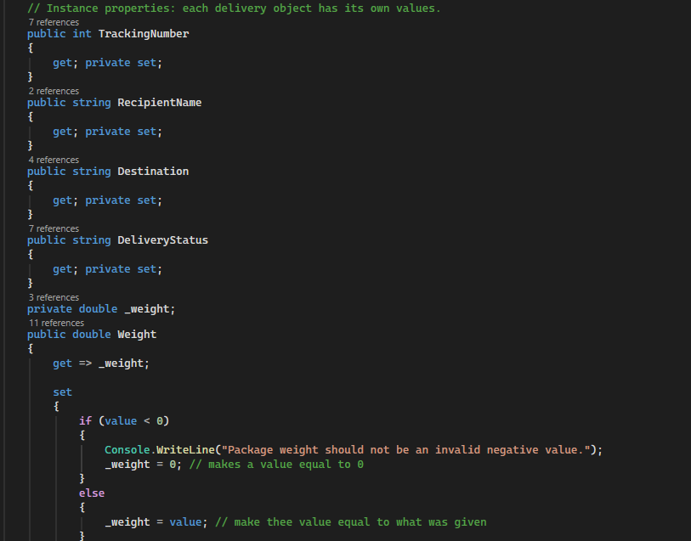

Inheritance and overridden behavior.
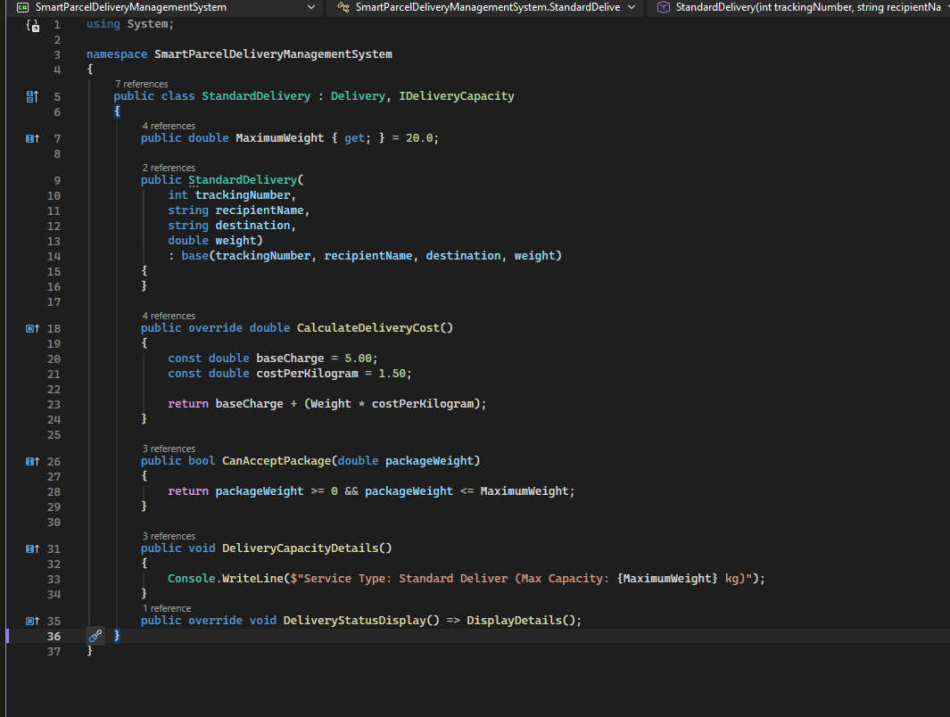

Interface implementation.
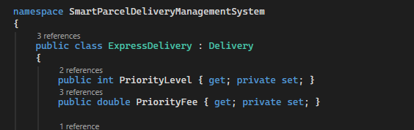

Reference-type behavior.
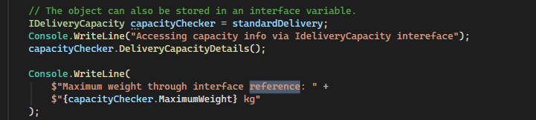

Clear console output showing that each required feature works.
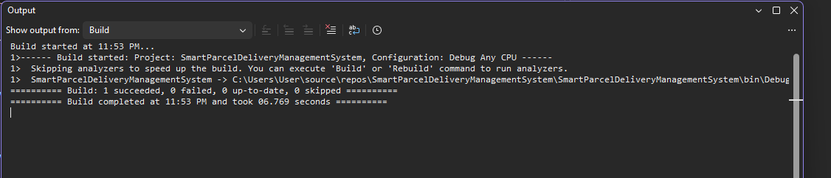
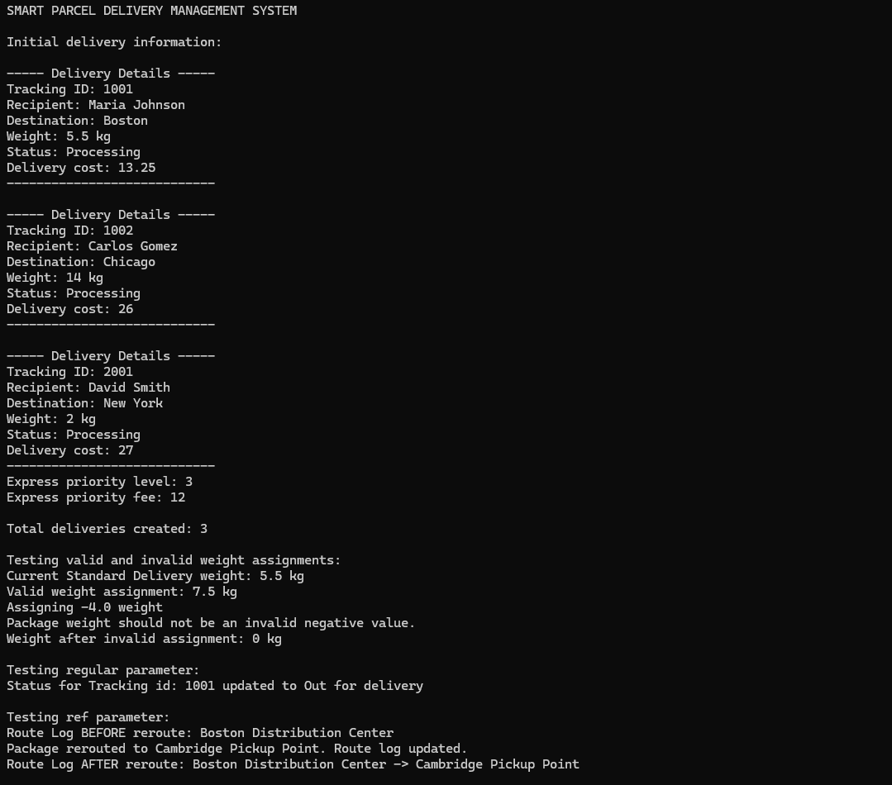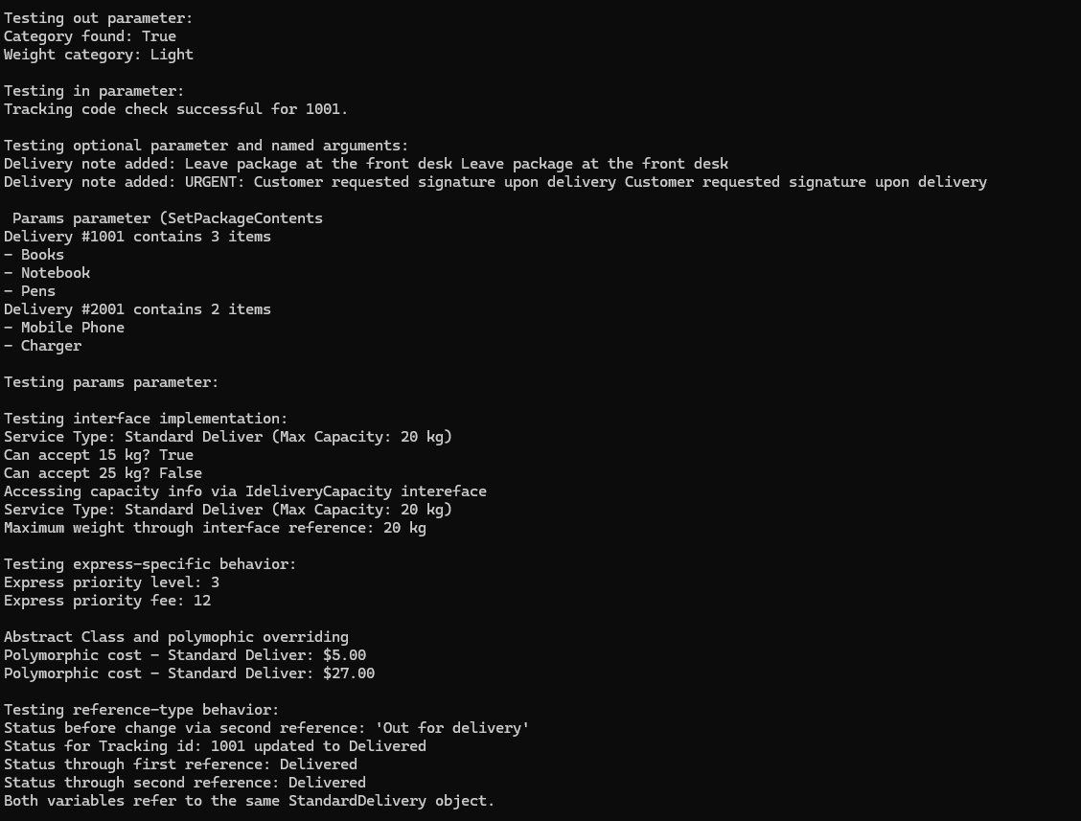
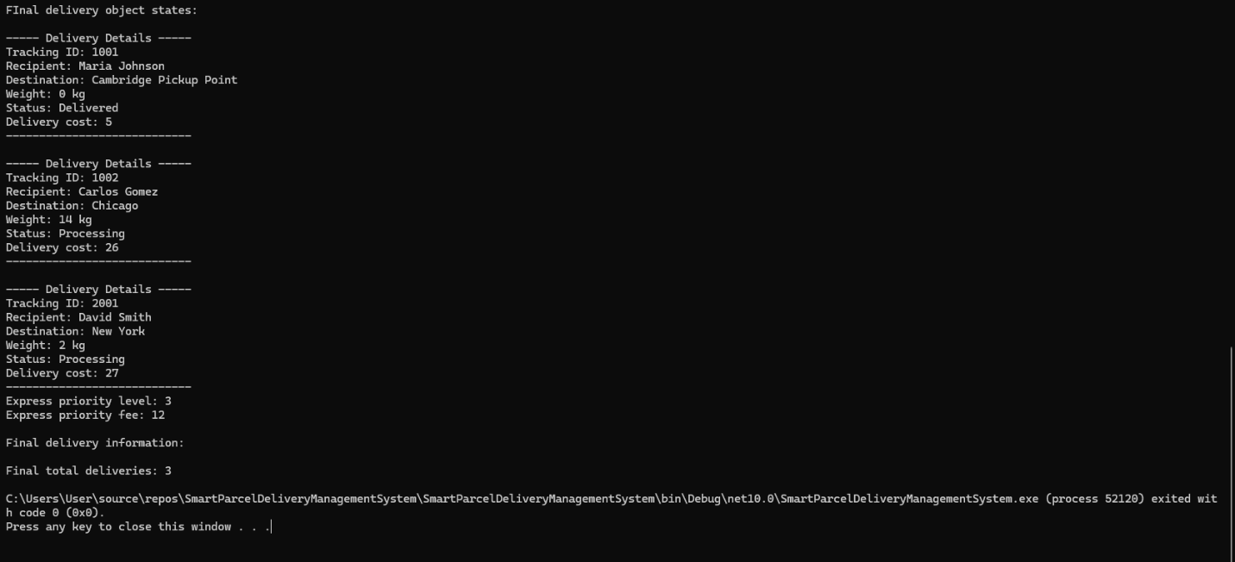

Gen AI disclosure:
I used gen AI to help debug important parts of the code and ask it to recommend alternative coding options that it gave me. I followed the gen AI disclosure instructions by first not accepting the code but using the diff method to compare the code to my own so I can think if it’s a better alternative.

